DBMS Lab: Mini Project Synopsis

Academic Year 2017-18

Class: TE IT A

**Group No.:-**

**Group Members:-**

|  |  |  |  |
| --- | --- | --- | --- |
| Roll No | Name | Mobile | Email |
| 35023 | Shubham Jadhav | 7769099521 | shubhamjadhav5678@gmail.com |
| 35024 | Avinash Jannu | 9623582559 | avinashjannu5@gmail.com |
| 35054 | Shantanu Sarode | 9975608447 | shantanu299@gmail.com |
| 35014 | Prathamesh Gavhalkar | 8484811626 | pgavhalkar@gmail.com |

**Synopsis:**

**Project Title**: Online Notice board automation system

**Problem Statement:**

* Implementation of online notice boards as an alternative to location based physical notice boards
* The online notice board automation system helps you to access online notices on your phone. It provides a proper view of notices with proper images, links and files.

**Literature Survey:**

* The existing system in which the notice board has displayed on notice board at the time this notice cannot reach to each and every one.
* Also Sending notices on messaging apps like whatsapp makes the notices difficult to manage. to avoid this type of system we use Online Notice Board Automation System.

**Scope of project:**

* In this system the admin is able to upload notices with their description and priority.
* Admin can also upload files like images and can select to whom to send the notice like HOD, staff and students.
* The college staff is able to send holiday notices, college event notices, task completion notices to students.
* The HOD’s can send notice for meeting to all the staff.
* The student can get an organized view of the notices with their assigned priorities and can also download the images or documents attached with it.

**Features and Functionality of project:**

### System Actors and User.

The system has three major actors and each actor has its features to carry out as follows:

#### Admin

Admin is the person who controls, monitors and keeps the whole flow of the system. The main functions of the Admin are:

* To keep and track down the total number of users in the system.
* Can add staff, students, activate and deactivate any user.
* Add New Notice and send notice to Registered users
* Display Old Notice and Manage Old notice
* Update Password
* Old notice vanishes after a particular date

#### Staff and HOD

* To keep and track down the total number of students in the system.
* Student Registration
* Can add, activate and deactivate any student.
* HOD can add, activate and deactivate any staff.
* Add New Notice and send notice to Registered users
* Display Old Notice and Manage Old notice
* Update Password

#### Student

Student is a knowledge seeker, or more theoretical word, a learner. The student has to be registered and log in into the system before he/she carries out their functions.

* Login
* Check Notification sent by admin,staff or HOD
* Update Profile
* Update Password
* Log out the whole system

**Schema Diagram:**

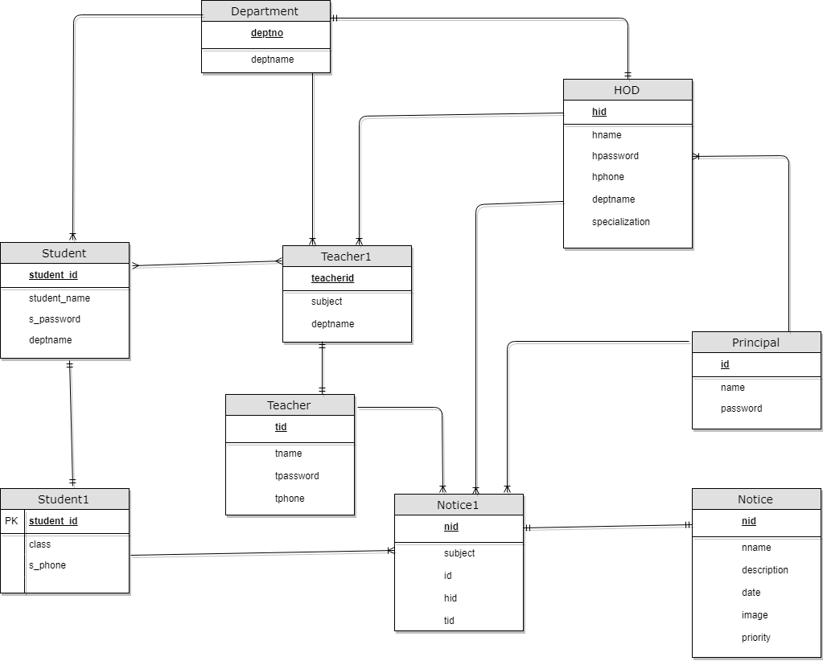

**ER Diagram:**

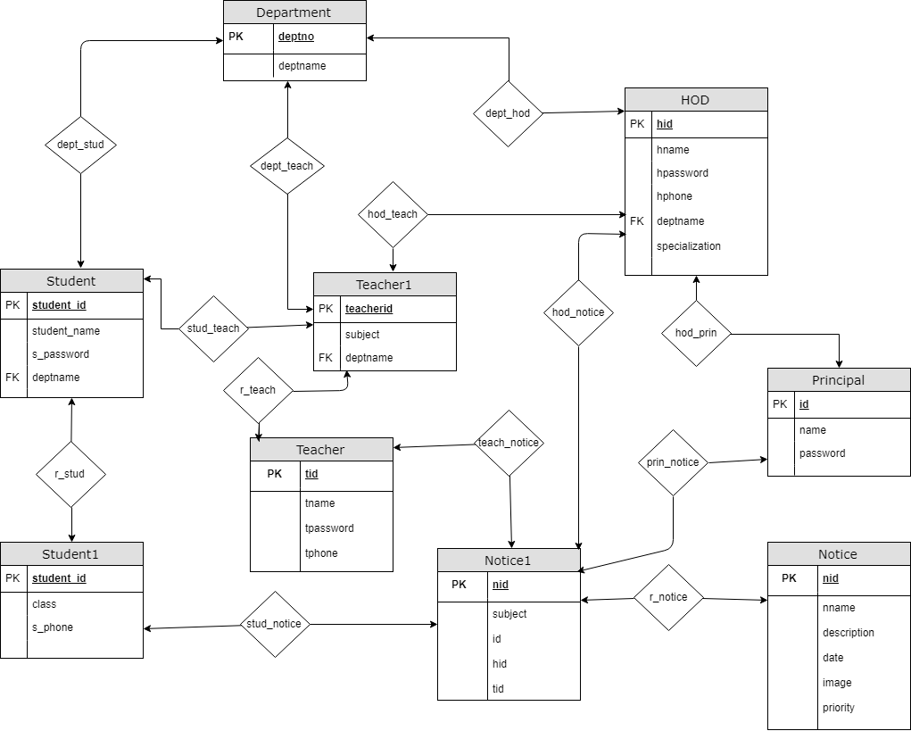

**Hardware and Software requirement:**

* **Software Requirement:**
* **Operating System :** Windows 7 and above.
* **Front end :** HTML, CSS, JavaScript.
* **Back end :** JSP(Java Servlet Pages), Servlets
* **Database :** MySQL Database
* **Hardware Requirement:**
* Minimum 100MB free disk space
* Minimum 4GB RAM

**References:**

* **Java Tutorials:-**

http://www.javatpoint.com

* **MySQL Tutorials:-**

https://javatpoints/mysql-tutorial